BLUETOOTH-CONTROLLED ROBOTIC ARM

ABSTRACT
This project presents the design and implementation of a Bluetooth-controlled robotic arm powered by an Arduino microcontroller. The robotic arm contain four DC motors, two motor consist of wheel movements and another two motor consists of arm movements. An Arduino Uno serves as the main controller, receiving input signals from a Bluetooth module (such as HC-05 or HC-06) paired with a smartphone. The Bluetooth interface provides an instinctive way for users to control the arm remotely via a mobile app, eliminating the need for wired connections.
The system's design includes a motor driver to control the four DC motors, providing the necessary power and control signals for accurate movement. The microcontroller interprets Bluetooth commands and translates them into motor actions, allowing for various arm movements, including picking and placing. This project serves as a prototype for applications in areas requiring basic automation and remote control, such as in small-scale industrial, laboratory, or educational environments. The Arduino-based approach ensures cost-effectiveness and ease of customization, making this project accessible for educational purposes and further enhancements.

INTRODUCTION
The development of robotic arms has opened new avenues in automation, providing precision and repeatability for tasks such as picking, placing, and assembling components. In this project, we designed a robotic arm controlled using Bluetooth module, powered by DC motors, and driven by an HW130 Motor Driver. The arm is wirelessly controlled via Bluetooth using an Arduino microcontroller. The use of the HW130 motor driver makes the setup more compact and energy-efficient, enabling smooth and reliable motor control.
The objective is to build a robotic arm with wireless control that is intuitive to operate and responsive to user inputs.

OBJECTIVES
- To design a wireless robotic arm controlled a HC-05 Bluetooth module.
- To implement efficient motor control using the HW130 motor driver.
- To provide multi-axis movement with DC motors for various joints of the robotic arm.

COMPONENTS
Hardware Components

. Arduino Uno
- Description: A microcontroller board based on the ATmega328P microcontroller.
- Specifications:
  - 14 digital input/output pins (6 can be used as PWM outputs).
  - 6 analog inputs.
  - 16 MHz quartz crystal.
  - USB connection for programming and power.
- Purpose: The Arduino Uno acts as the brain of the robotic arm, processing commands received from the Bluetooth module and controlling the DC motors.

DC Motors
- Description: Four DC motors to control the four joints of the robotic arm, providing movement in different directions.
- Specifications:
  - Voltage: Typically 6-12V (dependent on motor model).
  - Torque: Choose a motor with adequate torque based on the robotic arm’s weight and load.
  - Speed: Select motors with speeds suitable for smooth operation (e.g., 30-100 RPM).
- Purpose: Provide the necessary movement for each joint of the robotic arm.

Bluetooth Module (HC-05 or HC-06)
- Description: A Bluetooth module used for wireless communication between the robotic arm and a smartphone or any Bluetooth-enabled device.

- Specifications:
  - Operating voltage: 3.3V (often compatible with 5V when connected to Arduino).
  - Communication range: Up to 10 meters.
  - Default baud rate: 9600.
- Purpose: Enables remote control by connecting to the Arduino Uno via the serial communication pins (TX and RX) and receiving control commands from a Bluetooth app.

HW-130 motor driver module: It is a popular choice for small DC motor control projects. It’s a compact, low-cost motor driver based on the L298N dual H-Bridge IC, and it’s similar to the classic L298N module but often comes in a smaller form factor .
- Description: Provides power to both the Arduino and the DC motors.
- Specifications:
- Power Source: Battery pack or power bank (12V for motors, 5V for
Arduino).
- Motor Power: High-power batteries (e.g., Li-ion or NiMH packs) are
recommended to handle the current draw.
  - Arduino Power: Can be powered via USB or a separate 5V power supply.
- Purpose: Supplies sufficient power for the robotic arm to operate and supports high current requirements of DC motors without overloading the Arduino.

Chassis and Structural Frame

- Description: Physical structure that holds the motors and joints of the robotic arm.
- Material: Lightweight materials such as aluminum, acrylic, or high-density plastic to maintain stability while reducing weight.
- Arm Links: Should be robust enough to support the load and movement.
- Purpose: Provides a sturdy base and joints for motorized movement.

Miscellaneous Components

- Connecting Wires: For making connections between Arduino, Bluetooth module, motor driver, and motors.
- Connectors: Male and female headers or terminal connectors to simplify wiring.
- Mounting Hardware: Screws, nuts, and bolts to secure motors and frame parts.
- Robotic Arm Structure: A frame for mounting motors and actuators.
- Smart Phone: Operating devices like robotic arms or drones via Bluetooth commands. In projects like the Arduino-controlled robotic arm, Bluetooth enables a smartphone to wirelessly control the arm’s movements, providing a user-friendly, portable, and effective interface for remote operation.

SOFTWARE COMPONENTS
- Arduino IDE: Used to write and upload control code to the Arduino.
- Bluetooth Control Protocol: To transmit commands wirelessly.
- Embedded C Programming: For interpreting command inputs and controlling the motors.

SYSTEM DESIGN
BLOCK DIAGRAM
- Smart Phone: Send control signals for movement using commands.
- Bluetooth Module: Receives commands signals and sends them to the Arduino.
- Arduino Uno: Processes the signals and controls the motors via the HW130 motor driver.
- HW130 Motor Driver: Drives the DC motors based on signals from the Arduino.
- DC Motors: Actuate the robotic arm’s joints.

CIRCUIT DIAGRAM

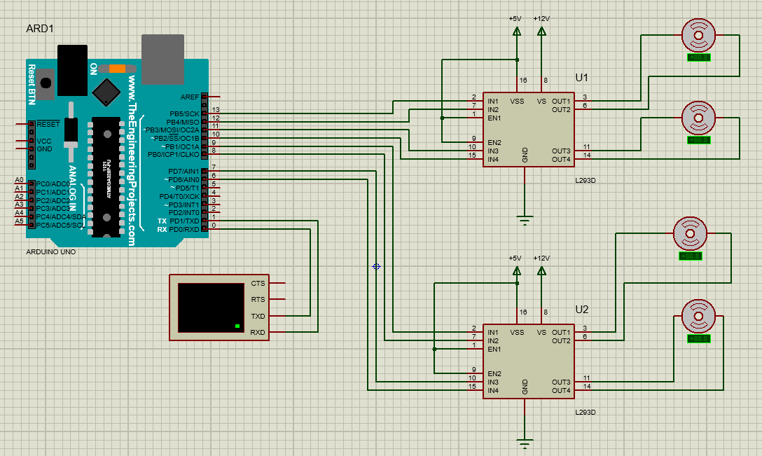

WORKING PRINCIPLE
The robotic arm is controlled using smart phone that transmit control signals via Bluetooth to the Arduino. Each command controls different movements of the arm. Command ‘F’ contain movement of FORWARD direction of wheels. Command ‘B’ contain movement of BACKWARD direction of wheels. Command ‘R’ contain to turn of RIGHT direction of wheels. Command ‘L’ contain to turn of LEFT direction of wheels. Command ‘U’ contain UP direction of Arm. Command ‘D’ contain DOWN direction of Arm. Command ‘O’ contain OPEN mode in gripper. Command ‘C’ contain CLOSE mode in gripper. The Arduino interprets these signals and controls the DC motors using the HW130 motor driver.
The HW130 motor driver provides a compact and energy-efficient solution for controlling the speed and direction of the DC motors. It is capable of driving two DC motors simultaneously, with bidirectional control for each motor.
Each motor controls a specific movement, and the speed and direction of each motor are controlled using Pulse Width Modulation (PWM) signals sent by the Arduino to the HW130 motor driver.

SOFTWARE IMPLEMENTATION
The software is written using the Arduino IDE, and it handles Bluetooth communication, and motor control using the HW130 driver.
The program reads the PWM to control the speed and direction of the motors. The Bluetooth module receives the command inputs wirelessly through smart phone, sending them to the Arduino for processing.

CODE

#include <AFMotor.h> // Include motor driver library
// Define motors
AF_DCMotor wheelMotor1(1); // Wheel Motor 1
AF_DCMotor wheelMotor2(2); // Wheel Motor 2
AF_DCMotor armMotor(3); // Arm Motor (up/down)
AF_DCMotor handMotor(4); // Hand Motor (open/close)

char command = 0; // Variable for Bluetooth command
void setup() {
Serial.begin(9600); // Set Bluetooth baud rate
}
void loop()
{
if (Serial.available() > 0) {
command = Serial.read(); // Read the command from Bluetooth
// Control Base/Wheel Movement
if (command == 'F')
{
// Forward
wheelMotor1.setSpeed(255);
wheelMotor2.setSpeed(255);
wheelMotor1.run(FORWARD);
wheelMotor2.run(FORWARD);
}
else if (command == 'B')
{
// Backward
wheelMotor1.setSpeed(255);
wheelMotor2.setSpeed(255);
wheelMotor1.run(BACKWARD);
wheelMotor2.run(BACKWARD);
}
else if (command == 'L')
{
// Turn Left
wheelMotor1.setSpeed(255);
wheelMotor2.setSpeed(255);
wheelMotor1.run(BACKWARD);
wheelMotor2.run(FORWARD);
}
else if (command == 'R')
{
// Turn Right
wheelMotor1.setSpeed(255);
wheelMotor2.setSpeed(255);
wheelMotor1.run(FORWARD);
wheelMotor2.run(BACKWARD);
}

// Control Arm and Hand Movement
else if (command == 'U')
{
// Arm Up
armMotor.setSpeed(255);
armMotor.run(FORWARD);
}
else if (command == 'D')
{
// Arm Down
armMotor.setSpeed(255);
armMotor.run(BACKWARD);
}
else if (command == 'O')
{
// Hand Open
handMotor.setSpeed(255);
handMotor.run(FORWARD);
}
else if (command == 'C')
{
// Hand Close
handMotor.setSpeed(255);
handMotor.run(BACKWARD);
}
else if (command == 'S')
{
// Stop all motors
wheelMotor1.run(RELEASE);
wheelMotor2.run(RELEASE);
armMotor.run(RELEASE);
handMotor.run(RELEASE);
}
}
}

RESULTS AND TESTING
The system was tested with the following results:
- Base Rotation: The base rotates smoothly in both directions.
- Arm Elevation: The arm moves up and down based on the command inputs.
- Elbow and Wrist Movement: The elbow and wrist joints can be controlled independently using the commands.
- Bluetooth Control: The smart phone was stable and responsive within a range of 10 meters.
- Motor Efficiency: The HW130 motor driver provided smooth and energy-efficient control over the DC motors.

APPLICATIONS
- Industrial Automation: Ideal for repetitive tasks in manufacturing.
- Remote Operation: Suitable for environments where human interaction is limited.
- Educational Purposes: Can be used for teaching robotics and wireless control systems.

ADVANTAGES
- Wireless Control: Bluetooth allows for remote operation, enabling more freedom of movement and reducing the need for physical connections.
- Cost-Effective: Arduino boards are relatively inexpensive, making the overall project affordable for hobbyists and educators.
- Ease of Use: Arduino’s user-friendly programming environment and extensive community support make it accessible for beginners.
- Modularity: Arduino supports a wide range of sensors and actuators, allowing for easy upgrades and modifications to the robotic arm.
- Real-Time Feedback: With appropriate sensors, the arm can provide real-time data back to the controller, enhancing control and interaction.
- Learning Opportunity: Building and programming a robotic arm is a great way to learn about robotics, programming, and electronics.

DISADVANTAGES
- Limited Range: Bluetooth has a limited range (typically around 10 meters), which may restrict the operational area of the robotic arm.
- Interference: Bluetooth signals can be subject to interference from other wireless devices, which might disrupt control.
- Power Consumption: While Arduino boards are efficient, a robotic arm may require significant power, especially if it has multiple servos or motors.
- Latency: Bluetooth communication may introduce some latency, which can affect the responsiveness of the robotic arm during operation.
- Complexity of Control: While basic operations can be straightforward, more complex tasks may require advanced programming and calibration.
- Limited Processing Power: Arduino boards may have limited processing capabilities compared to more powerful microcontrollers, potentially constraining more complex algorithms

CONCLUSION
The robotic arm controlled by Bluetooth module, DC motors, and an HW130 motor driver, successfully demonstrated. The HW130 motor driver provided reliable and efficient motor control, allowing the robotic arm to perform multi-axis movements with precision.

FUTURE SCOPE
- Additional Degrees of Freedom: More joints can be added for complex tasks.
- Autonomous Control: Incorporating sensors and AI for autonomous operation.
- Wireless Charging: Adding wireless power for more mobility and convenience.

